## **Screenshots**

**Pythons Interactive Shell**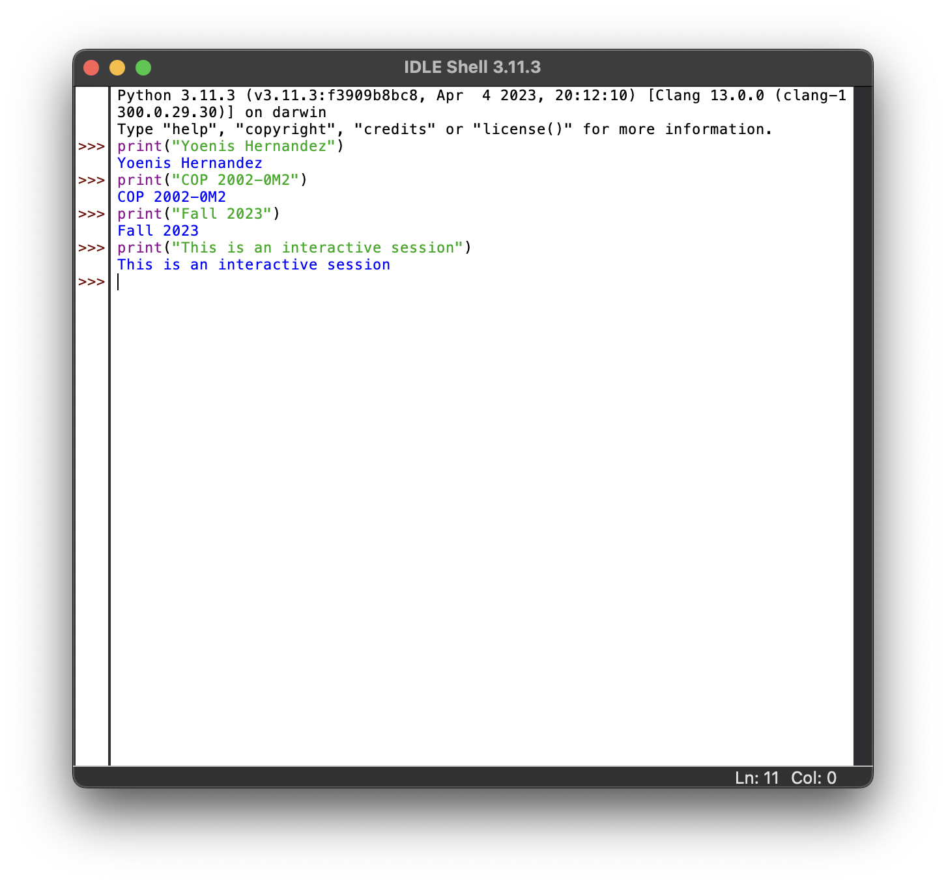

**Screenshot 1** 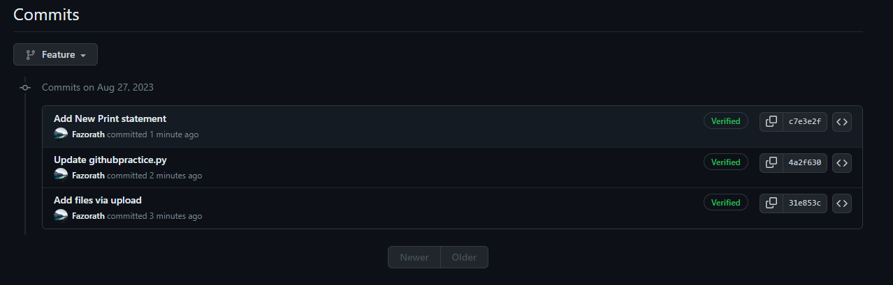

**Screenshot 2**

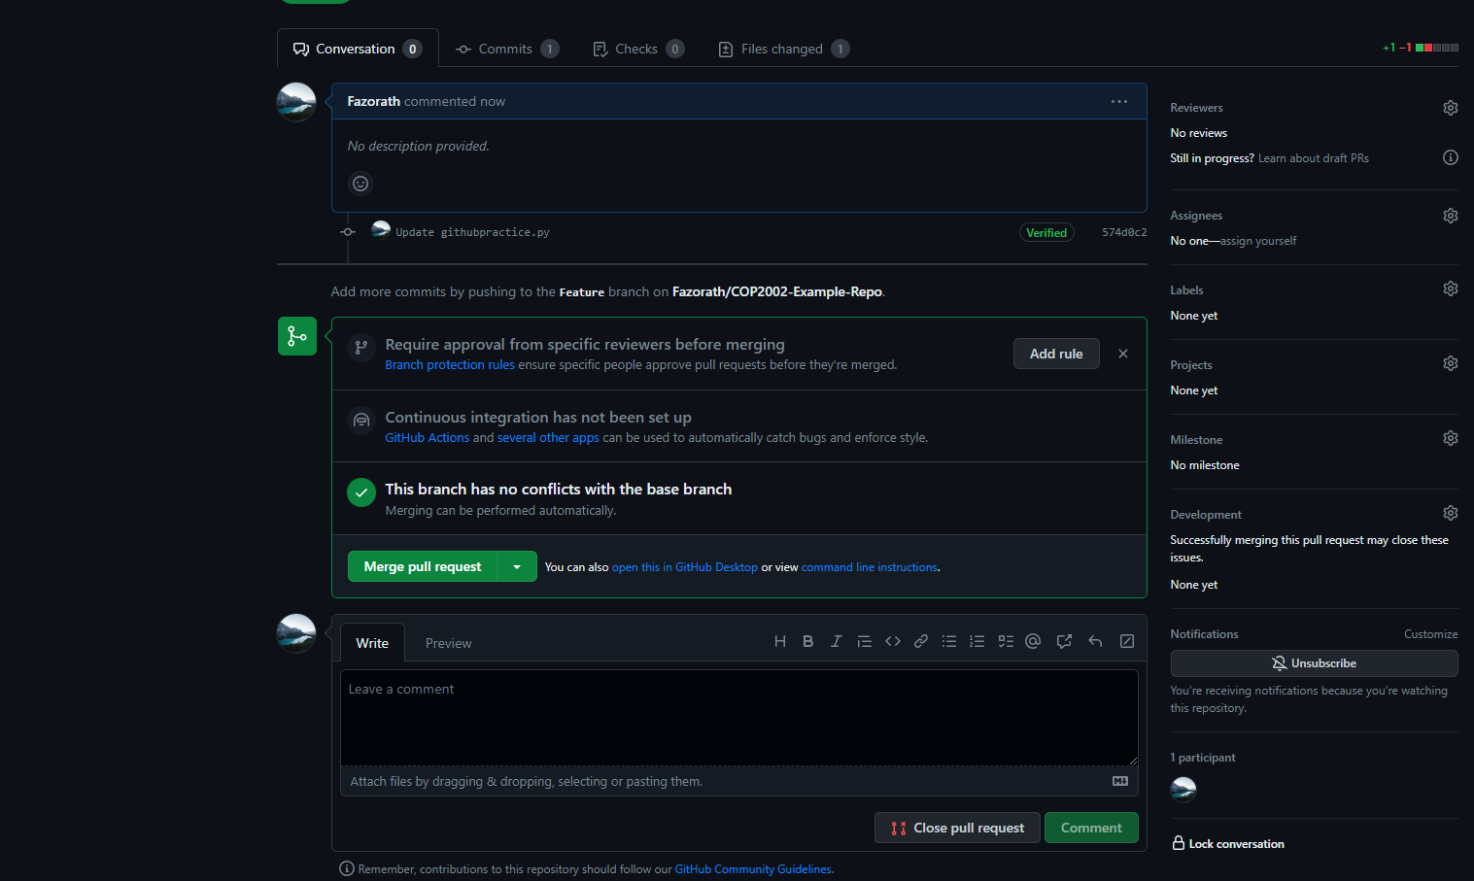

**Screenshot 3**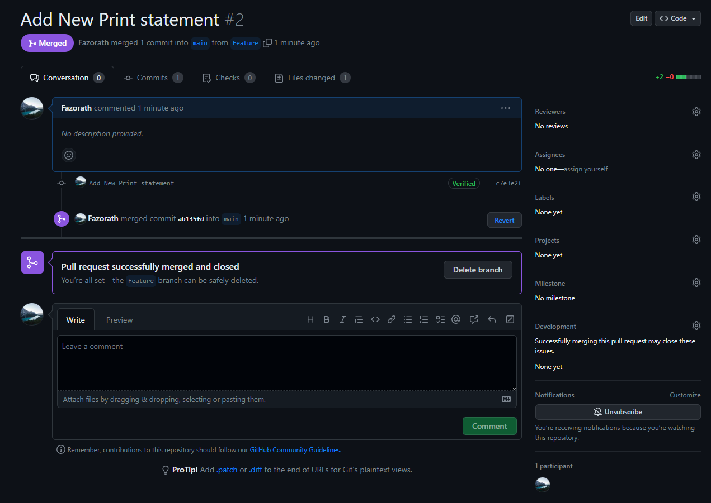

**Questions**

1. **What is the name of the default branch for a new repository?**

**The Name is *Main***

1. **Why do programmers and companies use GitHub?**

**Makes it easy to share code and files with other people. While also allowing to quickly revert to a previous version of the product allowing for unlimited testing and revising.**

**Git Hub Classroom**

